**Radix Sort**

Uses bucket type sorting based on place value

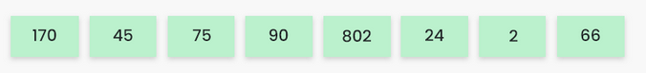

Largest value = 802

Length = 3

Max number of iterations = 3

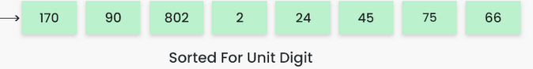

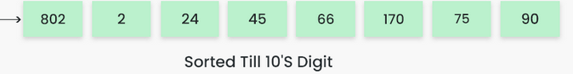

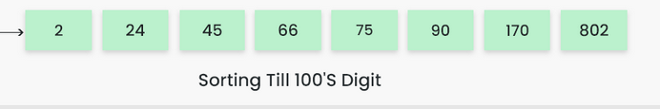

CODE:

def sort(arr,place):

bucket = [[] for i in range(10)]

for num in arr:

# get place-th value

divisor = pow(10, place)

idx = (num//divisor) % 10

# add to required position

bucket[idx].append(num)

# sorted

res = []

for i in range(len(bucket)):

for val in bucket[i]:

res.append(val)

for i in range(len(res)):

arr[i] = res[i]

def radixSort(arr, n):

# find largest value in array to know number of iterations

noOfIt = 0

for a in arr:

noOfIt = max(noOfIt , a)

noOfIt = len(str(noOfIt))

res = []

for i in range(noOfIt+1):

sort(arr,i)